Homework and English Language Learners
Tashia Hernandez, Mallory Babic and Kristen Cocco
EDU 496
Dr. Merryellen-Towey Schulz

Abstract
The purpose of this qualitative study was to compare the homework experiences of students who came from English speaking families to those who came from families with a different first language. This study attempts to shine light upon these comparisons to provide information to teachers and parents so that homework experiences for students can improve. In the literature review, we found that differentiation should be used when educating ESL students in the classroom. It also shares strategies that teachers should use when assigning homework to all students.
The participants of this study were students, parents and teachers. Information was collected through questionnaires and interviews. The student questionnaire asked questions to gain insight on the amount of homework students received, the feelings they had about homework and the people they have available to help them outside of school. The parents were asked questions about assisting their child(ren) with homework. Teachers were asked about the ESL population in the classroom and how they differentiate homework assignments for these students.
Introduction
The purpose of this qualitative study was to compare the homework experiences of students who came from English speaking families to those who came from families with a different first language.
Homework is assigned in schools all over the world. It is so common that sometimes people don’t question how often it is assigned or if it is effectively being used. Common themes found while researching homework were: ways to make it effective, debates on positive and negative aspects, and strategies teachers can use to assign homework that is meaningful.
During our field experiences, we observed ESL students are being assigned homework and not always being accommodated. This caused us to question why this was happening and what we can do as future educators to make a difference. The literature review shares what it means to be an ESL student, what types of homework are effective and laws pertaining to ESL students and education.
While preparing our research questionnaires, we wanted to discover parent and student opinions and feelings about homework. We asked teachers questions including: years of experience, endorsements, types of homework they assign, and why these are assigned.
Literature Review
Homework has been used in education for years, and it the past it was usually seen as a positive part of school. In more recent times, homework been questioned on whether it is necessary, which makes it a controversial topic. The word “homework” is commonly used in households with students in grades K-12 and seen as a norm in conversation regarding education (Vatterott, n.d).
During the 19th century, children played a large role in the household, so memorizing facts at home, which was a typical homework assignment, was a lower priority compared to the work they were required to do to help support their families. A lot of times, children could not continue on in school for this reason (Vatterott, n.d).
Starting in the end of the 19th century, the progressive education movements attacked the concept of homework for elementary school and junior high students until the 1940’s. Some researchers blamed the high amount of homework for the child mortality rate. Another anti-homework writer stated that homework was legalized criminality.
People continued to question the value of homework and there were many reasons it became controversial, until the 1950’s when people decided homework played an essential role in academic success. In the 1960’s, parents were actually worried that their children were not receiving enough homework and became concerned about academic success. It changed again in the 1960’s when people began to believe that homework put too much pressure on children. Throughout the 1980’s and 1990’s people believed that homework helped student achievement benefits and built character in students.
In recent times, the concern is not only based on the value of homework, but whether proper amounts of homework are being assigned. Although some research has been completed, results have been mostly inconsistent. (What research says about the value of homework: Research review). There were movements for homework and against homework throughout the entire 20th century (Vatterott, n.d).
There are two different purposes for homework stated by the Center for Public Education: instructional and non-instructional.
Instructional homework is usually assigned for four different reasons:
1. Practice homework is the most common type and it is assigned to give
students extra time with material that was presented and is supposed to get
students to the mastery level.
2. Preparation homework is assigned before the teacher has actually introduced
a topic and it prepares students for the future lesson.
3. Extension homework is assigned so students learn to apply skills learned in
the past to different subjects.
4. Integration homework is when students are expected to produce a product,
such as a presentation, project, portfolio, etc.

Noninstructional homework is also usually assigned for four different reasons.
1. Homework may be assigned for personal development in areas such as
behavior or time management.
2. Parent-child relations homework is assigned when the goal is to boost a
relationship between a child and his/her parent or guardians.
3. Peer interaction homework is assigned as group work so students are
encouraged to build teamwork skills.
4. Policy homework is assigned to fulfill requirements that a school or district
may have (What research says about the value of homework: Research review).
“The Northwest Regional Educational Laboratory in 2005 organized homework into four categories by type:
1. Memorization of basic rules, algorithms, or laws so the skill becomes rote.
2. Increase in skill speed, used for improving students' abilities to apply skills in
more complex problem solving.
3. Deepening understanding of a concept — providing students time to read
further, elaborating on a new idea and expanding understanding.
4. Preparation for the following day's learning, such as an advance organizer or
cue to increase readiness for new information.” (Danielson, Strom & Kramer,
2011)
Today, teachers graduate from a four-year University with a Bachelor’s degree and an endorsement as it pertains to their area of interest. Some teachers decide to obtain an ESL (English as a Second Language) endorsement. Teachers may wish to work with students who come from different countries, upbringings, cultures, and languages; other teachers may unintentionally have to work with students where English is their second language (L2) and some other language that is unfamiliar to that teacher might be their first language (L1).
Educators should be prepared to work with diverse groups of students. There will always be students in the classroom that will acquire modifications and accommodations. Differentiation is taught to teachers while they complete coursework for an undergraduate degree. When assigning homework, teachers must be willing to work with students who may not have the same resources available as other students. Parental involvement has been shown to have a positive effect on students and their educational achievements. While it is not always easy to gain parental involvement, teachers must become aware of ways to help students be successful with assignments they are required to complete outside of the classroom.
Definitions
Homework is a task(s) assigned to students by school teachers that is meant to be carried out during non-instructional time
Elementary schools include usually the first four to the first eight grades and often a kindergarten
Junior high schools are attended after elementary school and usually consist of grades seven through nine
High schools are attended after junior high school and usually consisting of grades 9 or 10 through 12
Special education is education for children who have special needs because of physical or learning problems, also includes gifted children (Merriam-Webster’s online dictionary, n.d.)
English as a Second Language (ESL) is the study of English by nonnative speakers in an English-speaking environment (Dictionary.com, n.d.)
Language 1 (L1) is the first language that a person acquires and is commonly the language spoken at home
Language 2 (L2) is the second language that a person acquires
No Child Left Behind Act is a law affecting grades K-12 in the United States that came about in 2001 that is" based on four principles of educational reform including: stronger accountability for results, increased flexibility and local control, expanded options for parents, and an emphasis on teaching qualifications and methods" (No Child Left Behind Act (NCLB): An Overview, n.d.)
Aliens are individuals who are not U.S. citizen or U.S. nationals
U.S. Citizen
1. An individual born in the United States
2. An individual whose parent is a U.S. citizen.*
3. A former alien who has been naturalized as a U.S. citizen
4. An individual born in Puerto Rico
5. An individual born in Guam
6. An individual born in the U.S. Virgin Islands.
*The Child Citizenship Act, which applies to both adopted and biological children of U.S. citizens, amends Section 320 of the Immigration and Nationality Act (INA) to provide for the automatic acquisition of U.S. citizenship when certain conditions have been met. Specifically, these conditions are:
1. One parent is a U.S. citizen by birth or through naturalization;
2. The child is under the age of 18;
3. The child is residing in the United States as a lawful permanent resident alien
and is in the legal and physical custody of the U.S. citizen parent; and
4. If the child is adopted, the adoption must be final.
Immigrants are aliens who have been granted the right by the USCIS to reside permanently in the United States and to work without restrictions in the United States. Also known as a Lawful Permanent Resident (LPR). All immigrants are eventually issued a "green card" (USCIS Form I-551), which is the evidence of the alien’s LPR status. LPR’s who are awaiting the issuance of their green cards may bear an I-551 stamp in their foreign passports
Illegal Aliens are also known as an "Undocumented Aliens," is an alien who has entered the United States illegally and is deportable if apprehended, or an alien who entered the United States legally but who has fallen "out of status" and is deportable (IRS, 2014)
Some people may find the terms “illegal” or “alien” to be offensive. Throughout this literature review, the terms “undocumented” and “immigrant” will be used in their place. “LPR, Lawful Permanent Resident” is a term that was not listed on the IRS’s website. The U.S. Department of Visas defines an LRP as an immigrant who is residing in the U.S. and has been granted the privilege of permanently living and working in the United States. They go on to explain, “If you want to become a lawful permanent resident based on the fact that you have a relative who is a citizen of the United States or is a lawful permanent resident, your relative in the United States will need to sponsor you and prove he/she has enough income or assets to support you, the intending immigrant(s) when in the United States” (U.S. States Department, 2014).
Immigration History
Before today’s strict border policies and immigration laws, there were hardly any borders and the people of America and Mexico crossed the country lines as they pleased. At the beginning of the century, the United States imposed some regulations to immigration such as, the prohibition of immigration of contract laborers in 1885. In 1917, All Asians (except for Filipinos) and illiterates were prohibited from entering the country (Mintz & McNeal, 2013). But there were not many in the way of laws or a process to become a citizen. From the time that part of Mexico had become the United States to World War II, the United States’ borders were open to Mexicans for seasonal work flows in the fields of America.
Once World War II broke out, many Americans were being sent overseas to fight in the war, which lead America into a recession and in need of the man-power to keep the industrial field of America going. This lead to the “Braceros Program”, an agreement that Mexican citizens could cross over the borders to work in the United States with a guarantee to be paid at least 30 cents per hour. Once the Bracero Program ended in 1965, many of the workers stayed in the United States even though their contract was up. This lead to an increase in illegal flows of immigration and later in 1986, the Immigration Reform and Control Act was passed by congress (Rosenblum, Kandel, Seelke, & Wasem, 2012).
Today, the United States has a complex system for granting permission for immigrants to come into the country. They allow 675,000 immigrants to legally enter the country annually (excluding refugees), with certain exceptions for close family members. According to the American Immigration Council, the U.S. allows people to migrate based on the following: “the reunification of families, admitting immigrants with skills that are valuable to the U.S. economy, protecting refugees, and promoting diversity”. In order to become a U.S. citizen, the person must have had their LPR status for at least 5 years. To apply for citizenship, the individual must:
1. Be at least 18 years old
2. Demonstrate continuous residency
3. Demonstrate “good moral character”
4. Pass English and U.S. history and civics exams
5. Pay an application fee, among other requirements ("How the United
States Immigration System Works: A Fact Sheet | Immigration Policy Center," 2014).
Throughout America’s history, many different cultures have migrated to the United States both legally and illegally. Europeans, Japanese, and Hispanics are some of the larger groups of immigrants to have migrated to the U.S. during the 20th Century. Even though all of these immigrants come from different cultural backgrounds, they have all been looked down on by Americans, and their migration to this country has created controversial matters. In the past the immigrant population was constantly changing based on the cultural group that was migrating to America.
Demographics
Today, 46 percent (18.9 million) of immigrants in the U.S. are Hispanic. Nearly 11.6 million immigrants are from Mexico, according to migrationpolicy.org, which accounts for 28.3 percent of all U.S. immigrants. Since 1980, immigrants from Mexico have been the largest national-origin group in the United States. As of 2012, it has been estimated that the population of undocumented immigrants in the United States is 11.43 million. Research has also found that about 59% of the undocumented immigrants in the country are from Mexico which is because it is a neighboring country.
Laws
With the increasing number of immigrant families coming to the United States, a large number will have several kids who will require education. According to the Free and Public Education act under section 504, also known as FAPE, in the United States, all children have the right to a free and public education. This means that all children, students with disabilities, ESL students, and also mainstream students, all have the right to a free and public education in the United States.
Free and public education should also be appropriate education, too. Appropriate education may be comprised of following: education in regular and mainstream classes, inclusion education in these same mainstream classrooms with the use of outside services and accommodations, or possibly even special education or other related services in classrooms other than the general education classroom. During this appropriate education for pull-out classrooms, students may attend these additional services for minor parts or all of the entire school day. Regardless of the need of the student whether it be in general education, extra services, or special education, every child is granted a free and public education that is appropriate for them under the FAPE Act under section 504 of the IDEA act.
According to an article composed by members of The Center for Applied Linguistics and The CNA Corporation “Title III of the No Child Left Behind (NCLB) Act of 2001 requires districts to provide educational programming, testing, and other services for all students, including English language learner students, to ensure their academic success (p.3).” Also according to another source written by Chang Pu from Berry College, “By federal law, school districts are required to offer English as a second language (ESL) services to language minority students to improve their English language proficiency skills” (Pu, 2010, p.2). This means that not only do children receive a free and public education, but students who have English as a second language (L2) are required to be granted ESL services by the federal law, in order to improve on their English language proficiency skills.
The changes in the demographics will in fact bring students to the United States for a free and public education, where every student can receive the appropriate education that is needed. This means that money or socioeconomic status does not play a role in determining if a student is granted education or not. However, because every child is granted a free and public education does not mean that every child is receiving the same education across the nation.
“The No Child Left behind Act of 2001 requires schools to track academic disparities by disaggregating data on standardized test performance by various socioeconomic and demographic characteristics. Taken together, many of these characteristics, such as race and ethnicity, low English proficiency, and poverty, effectively identify immigrant groups, leading to more, albeit indirect, monitoring of the progress of immigrant youth in public schools (Crosnoe, López Turley, 2011).”
The results of the No Child Left behind Act of 2001 show that students in areas of poverty and that of which have low socioeconomic status do not have the same performance on standardized testing as those students who come from a wealthier area. This just goes to show that a free and public education does not grant the same education across the board.
In their report to the National Clearinghouse for English Language Acquisition, Ballantyne, Sanderman, and Levy (2008) noted that there are over five million students limited in English in the U.S., a 57% increase over the past 10 years. Nearly six in 10 of these ELLs are recipients of free or reduced price lunch, which indicates that their families are from low economic status backgrounds (Nguyen, 2011).
Even though students may come from low-income families, students will still have access to an education. However, the education in a wealthier society may not be the same as those living in an area with poverty. “Not surprisingly, such group differences in socioeconomic status are linked with differences in educational outcomes (Crosnoe, López Turley, 2011).” According to Crosnoe and Lopez Turley, 2011, given the power of socioeconomic status to stratify opportunities to learn in the United States, socioeconomic diversity in who selects into emigration from another country contributes to the diversity in outcomes among children of immigrants in this country.
Education for ELLs
When undocumented students begin attending school in the U.S., they usually enter the grade they are supposed to be in, even if they do not speak English. If a student speaks a language other than English in the home, they will be tested to see if they are proficient in English. If the students passes the test, they are put into the general education classes, and learn the same content as the other students in the school. If the student is not proficient in English, they will be assigned to ESL (English as a Second Language).
The Pull-Out English as a Second Language program removes students from mainstream classrooms for a portion of the day in order to give them specialized instruction in English. Pull-out ESL is most common in elementary schools where a designated ESL teacher works with small groups of children on their reading, writing, and speaking skills in English. Pull-out programs do not usually incorporate the lessons going on in the English class (Hunemorder, 2005). Therefore, students pulled out for ESL help, are forced to miss instructional time in their mainstream classes, which causes them to fall behind in their academics. ESL students are tested annually to check their English proficiency.
Once a student has passed all levels of the ESL program and are proficient in the English language, they graduate from ESL and no longer need ESL assistance. In the Omaha Public School District, there 7,000 English Language Learners (14.4% of the total OPS population) that currently participate in the ESL program in grades K-12 ("ESL - Curriculum Instruction and Assessment - Omaha Public Schools," 2014). Because the Omaha Public School District’s ELL population has grown significantly, their ESL program has expanded as well, and assistance is available to every student in the district. Below is OPS’s ESL mission and philosophy:
“The English as a Second Language program responds to the needs of English Language Learners in an effort to provide optimal educational opportunities for them. The program provides the following:
1. Specialized instruction that develops the students’ abilities to read, write,
speak and understand English.
2. Preparation for students to participate fully in the curriculum of the school.
3. Support for the maintenance of the students’ first language and pride in the
cultural heritage of each student. ("ESL - Curriculum Instruction and
Assessment - Omaha Public Schools," 2014)
Characteristics of Effective Homework
In a Turkish study, 168 middle school science teachers were asked about homework. 93.4% of the teachers admitted to assigning homework at the end of the class up or at least once a week. The most common types of homework were problem solving and research and the least common were memorization of facts and summarizing. In this study, teachers were also asked about value of homework. Teachers with smaller class sizes placed more value on homework, and those who did were more likely to discuss homework with parents (Tas, Vural & Oztekin, 2014).
When homework is so commonly used it should be created and implemented appropriately, so it is a valuable way to reinforce learning. Unfortunately, many teachers are not using homework effectively, it is just routine. If teachers look at research and find what works, they will be more successful in helping their students become successful with assignments that are expected to take home.
There are many things that can play a role in homework being effective: accommodations, organization, structure, technology, parent communication, and home life. Differentiation is something that all teachers need to be able to do, especially when assigning effective homework (Schrat Carr, 2013).
Effective homework will combine basic skills with chances to use critical thinking skills, not just right or wrong answers. It should encourage parental involvement and be aligned with educational goals (Alleman, Ley, Knighton, Botwinski, & Middlestead, 2010). To support educational goals, the assignment should take into account student needs and abilities. The assignment strengthens school-home link, rather than weakening it (Protheroe, 2009).
In Five Hallmarks of Good Homework qualities of effective homework include: purpose, efficiency, ownership, competence and aesthetic appeal.
1. To create purpose in an assignment, it should work for various learning styles
and create connections in the students’ minds. If homework is purposeful, the
teacher will gain knowledge about student understanding and be able to make
adjustments to instruction.
2. Efficient homework requires thinking of students and is not just “busy work”.
3. Ownership is when students develop a personal relationship with the content
of the homework and this may mean thinking outside of the box when giving
students assignments to complete at home.
4. Competence is necessary for students because if they cannot do it
independently, it is not effective. Differentiation so students are able to do this is
the teacher’s responsibility.
5. Aesthetic appeal is important because students will be more inclined to
complete homework that is not cluttered or multiple pages long (Vatterott, 2010).
Teachers should always provide feedback on the homework they give; sometimes it is just graded and the child never receives comments or constructive criticism that would help them to do better next time or take more away from the assignment. Homework can also really help special education students if extra practice is the purpose of the assignment and especially if it encourages the parents to be involved (What research says about the value of homework: Research review). Effective homework has not only one purpose, but meets the needs of individual students. Some schools have experimented with removing homework, but in most cases, homework will be assigned. Teachers should do their best to create effective homework assignments to ensure student success.
Homework completion usually has an effect on grades, and fair is not always equal. Students who are ESL might not be able to complete due to not understanding American assignments, or even worse they might not have the skills needed to complete the homework. This may be due to a language barrier, but also could relate to lack of resources due to poverty. Each of these factors places the ESL youth at a disadvantage (Bang, Suarez-Orozco, & O'Connor, 2010).
For ESL students, homework is helpful because they are able to use the learning opportunities to build their English skills as well as content knowledge. To help these students understand the importance, teachers can emphasize doing homework in a lot of rules so that way they see it as part of their job as a student (Bang, Suarez-Orozco, & O'Connor, 2010). Another issue is that homework has been proved more beneficial for older kids than elementary students. Statistics show that lower income students may not benefit as much as people with money from homework requirements (What research says about the value of homework: Research review). This can be because students with higher income have more resources available to them, usually (What research says about the value of homework: Research review). Lower-income students tend to have lower average scores than students who are from families with more income. There was a study where parents of the lower-income students were interviewed on the role they played in their child’s academic success.
Studies have shown that these parents are less likely to be involved with student work because they have less time and flexibility; they are more focused on basic needs of the children and at times have a lack of confidence. When these parents were interviewed, they shared that they were more likely to assist children with reading or English homework, instead of math or other subjects. Overall, the parents thought involvement was highly important, but they varied in what was more important to assist kids with (Drummond & Stipek, 2004).
Homework Strategies for Teachers
Teachers can do many things to keep the assignments they expect students to do at home effective. Alfie Kohn shares a simple enough way for this to happen: ask the students. Teachers can ask the students how they feel about homework and which assignments they prefer to do when they are not at school. This alone can help teachers take into account what may be too challenging for some students to do at home or what just seems like busy work (Kohn, 2007).
In a study, students were asked what really helps them do better on homework. The things the students shared can be great strategies and tips for teachers. Students benefit when the teacher assigns homework at the beginning of class with clear oral and written directions. A sample of an exceptional assignment also helped students prepare for the homework, especially if they were given time in class. Other tips provided by the students were relating the homework to classroom instruction and allowing the students to work together (Protheroe, 2009).
Homework assignments should not be one-size-fits-all. When assigning math homework, it is common for teachers to give homework that consists of numbers 1-41, odd problems only. The teacher should assign fewer problems and then ask questions that assess understanding of the students (Vatterott, 2010). Teachers should also only assign ten minutes of homework each night for the grade they are in. For example: 1st graders = 10 minutes, 2nd graders = 20 minutes, 3rd graders = 30 minutes, etc. This does not mean they have to assign this much, but they should not go over it.
Before assigning reading as homework, teachers should activate background knowledge, promote student interest and set a purpose for reading before assigning reading for homework. It is stated that in middle school teachers should include formative assessments that hold students accountable for reading homework (Sutherland, 2008).
Research has shown that homework should not be used to teach new material. While it is considered acceptable to use homework as a means to introduce things that will be taught later. That way, students are able to expand on these assignments. Homework also should not be given in the same manner every day; it should be assigned when there is purpose for the students and it should be developmentally appropriate (Protheroe, 2010).
Teachers should help students build learn self-regulating skills. Teachers can encourage students to set goals, use different learning strategies, be motivated, monitor self-progress, and evaluate their own homework. Students are not born with these skills, teachers help students to master them.
Most schools assign each student agendas, and this is one way to help students stay organized. Students can keep track of when things are due, important dates and other school-related activities. If teachers remind students of due dates often, the students will be more likely to remember the assignment and turn it in on time. Teachers should have students evaluate themselves and reflect on assignments often so that way they learn to think critically about how they can improve (Schrat Carr, 2013).
Teachers should assign different types of homework. If too much summarizing and memorization homework is assigned, students will think that is what homework is. If too much creative homework is assigned, students will believe that homework always requires creativity (Tas, Vural & Oztekin, 2014).
When teachers are planning homework assignments, there is a method that they can follow that is tri-dimensional. The assignments should be reasonable, relevant and reinforcing. A reasonable assignment would mean that the student could complete it independently in the time frame given, because it is at the appropriate level for the individual student. A relevant assignment would be related to concepts discussed in the classroom. Students would understand the purpose and be aware of the objectives and standards for the assignment. An assignment that reinforces expands on the knowledge gained from classroom instruction by allowing the students to practice applying skills to become critical thinkers. By asking these questions, teachers can use this method to justify homework assignments (Danielson, Strom & Kramer, 2011).
Accommodations, Planning, and Differentiation
To accommodate students’ learning needs in mainstream classrooms, teachers must know how and when to modify instruction and build on their students’ existing knowledge (Gersten et al. 2005). In terms of ESL students, modifications and accommodations are particularly important for the success of these students. All teachers, not just those working with ESL students, have to modify their lessons and means of instruction in order to reach all students. Teachers must know where each and every child is at academically, in order to build onto that existing foundation of knowledge.
According to researchers at the Mid-continent Research for Education and Learning, studies show that “The teacher understands how students differ in their approaches to learning and creates instructional opportunities that are adapted to diverse learners. There are recommendations for required knowledge and skills. Teachers demonstrate an understanding of communication skills and be able to apply them appropriately with parents and other adults” (2012, p. 11). Teachers should be qualified enough to have a concise understanding on how to meet the needs of these learners through accommodations.
Before providing accommodations to a student, the teacher must have an understanding of each and every student, adaptations of content for that particular student, and apply appropriate communication skills in order to work with these students. Although teachers may attribute an ESL student’s struggles with school work to cognitive ability, the problem may actually be related to background knowledge rather than intellectual ability or curiosity (Short and Echevarria 2005) (Misco & Castañeda, p.184, 2009). Once the teacher is able to identify the background knowledge of the student first, then the teacher can make the appropriate accommodations that are necessary for the success of each student within his or her classroom.
Common accommodations that have been proved to be appropriate for ESL students come from many different areas such as the environment, assignments, materials, presentation, management, and classroom assessment. Within each category, some of the accommodations that can be made for a student may include some of the following: assign a peer tutor, highlight key words, visual charts/cues, single step directions, adjust reading level materials, use manipulatives, native language text, repeat all directions, and modify format/length of text, just to name a few.
There are all very basic, common, accommodations that can be made for an ESL student who receives extra services. Although one student may only need one accommodation, another student might receive five. This all depends upon the student and their individual needs.
Because undocumented students are either learning a new language or trying to acculturate, educators have to find different approaches to teaching that will benefit their students’ educational growth. Citizenship education provides an opportunity for learners to better understand their cultural knowledge, which is why World Geography Studies as an introductory social studies course for late arrival immigrant students is useful. Courses such as this are beneficial to immigrant students because it helps the student to learn about the American culture and history while also maintaining their cultural values (Salinas, Sullivan, & Wacker, 2007).
Wilma Ortiz, a teacher in Amherst, Massachusetts has found that it is important to make her ELLs feel that they are a part of the school community to avoid a sense of not belonging and other mental struggles that immigrant students face. She did this by having her students volunteer around the school, which not only got them involved in the school, but also helped them to work on their English speaking skills (Caperton, Washington, & Bushaw, 2011).
Brandy De Alba, an eighth grade teacher in Stockton, California has found a couple of strategies to help her immigrant students. She supports her students’ parents by keeping contact with them and asking if there is any way she can assist them with their student. By doing this, De Alba has more support from her parents. In De Alba’s classes, she also emphasizes the importance of writing to her students. At first it is a struggle for her students, but after hours of practice, Brandy reports that her students become comfortable with writing in English and begin to find it easier to express themselves in this way (Caperton, Washington, & Bushaw, 2011).
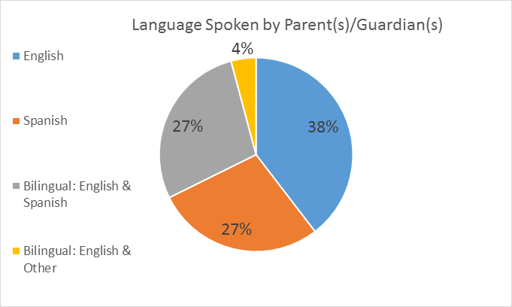
Sharon Ornelas, an ESL teacher, has worked with many different cultures in her teaching experience, therefore has taught English to students of various native tongues. Ornelas has often been asked, “Which teaching methods work best with these populations? Do different groups need different strategies or do they all respond to similar teaching methods?” Sharon responds, “Group information is helpful up to a point. But all kids are individuals, both of their culture and not of their culture. Every kid is an exception in some way, linguistically, culturally. It’s important to know what different cultures value but it’s also important to know that every kid in that culture does not fit into that mold.” (Caperton, Washington, & Bushaw, 2011)
Methods
Design
The researchers chose to use qualitative methods because this type of research allowed students, parents and teachers to express their experiences with and opinions of homework. Researchers created an online questionnaire that was posted online as well as sent to specific students, teachers and parents. The participants were not asked to identify themselves by name, but some demographics were obtained.
Population
The population of the participants included a mixture of parents, students and teachers. The population consisted of students ranging from grades K-12. Some students came from English speaking homes and others had parents who spoke different languages. The teachers are currently employed at various schools in Omaha to L1 and L2 students. The parents were those who had students in grades K-12. The researchers chose this population to gain insight on homework experiences from a variety of participants who have different perspectives.
Limitations
The main limitation for this research was time. In the amount of time we were given, we were able to gather data, but we would have preferred more time to seek out participants who were willing to be videographed. Originally, the goal was to have video footage of face to face interviews, but we found that most participants did not want to be videographed. Some participants responded to the online questionnaire without answering all of the questions. We had the largest amount of student responders, followed by parents, and the least amount of teacher responders. We were hoping to have more teachers complete the questionnaire, as they are the ones who decide which homework is assigned.
Data Analysis
This graph shows the languages their parent(s)/guardian(s) spoke at home. When students were asked how they felt about homework, over 60% of them had negative responses. Students who had parents who spoke only Spanish at home were expected to have more negative responses at the beginning of the study.
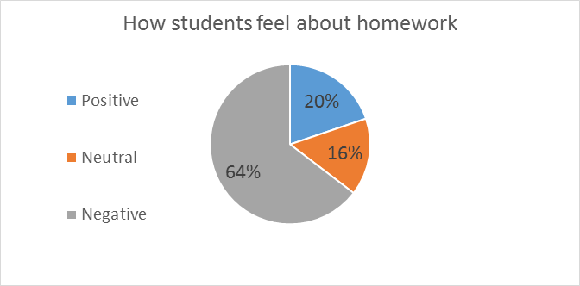
After analyzing student responses, students with English speaking parents responded with 77% negative comments. 11% responded positively; 11% responded neutrally. Students with Spanish speaking parents responded with 75% negativity. 8% responded neutrally to having homework and 17% responded positively. Students with bilingual parents had 40% negative feelings. 40% also responded with neutral feelings. 20% responded with positive comments.
Every student surveyed admitted to having homework at least sometimes every single week. The majority of students had homework every single day.
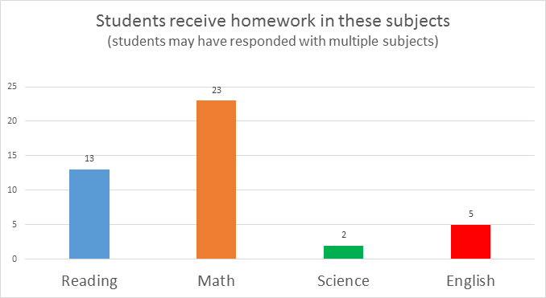
It was surprising to see that students with English as a first language had more negative responses than students who had parents that only spoke Spanish, although it was only 2% more.

Common themes found during analysis of the student questionnaire responses, were that students thought homework was a waste of time; it was also thought of as boring and repetitive. Those kids who liked homework, usually had a comment that would encourage some type of change in the homework that they were assigned.
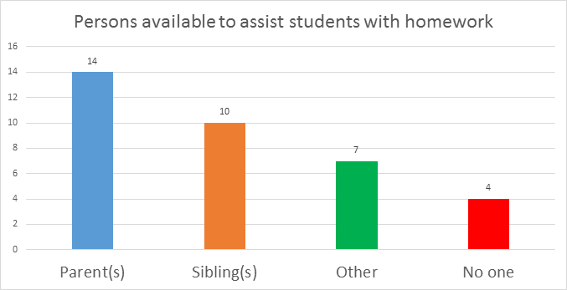
Students with Spanish speaking parents reported the majority of help with homework coming from siblings, at 39%. 28% of those students reported having help from either their mother, father, or both. 22% of these students had no one to help them at home due to a reported language barrier.
Students with English speaking parents admitted to having 50% of their assistance come from their mother, father, or both. Only 7% of these students had help from siblings. 14% of them had no help at all. 29% of their help came from other people such as grandparents and after-school care providers.
Students with bilingual parents had equal help from parents and siblings with 40% of help from each. The remaining 20% said that they had no one to help them with homework at home. These numbers were the most interesting, because it can be inferred that the students with Spanish speaking parents were able to receive help from their siblings who learned English at school as well.
Students with English speaking parents and bilingual parents both had a pretty large amount of help coming from the parents who were more likely to be able to understand the homework being assigned; especially when the most commonly assigned homework is math and reading.
When asked "How do you feel about receiving homework?" some responses were:
"Mad and bad because I have other things to do when I get out of school and
sometimes don't have enough time to do it and get in trouble at school."
"Sometimes it's hard, but I like doing it. It's fun."
"Exhausted yet relieved I get to learn more."
"Kind of bored with it because it's usually the same stuff."
"I feel grumpy when I get more than two pages of Math homework."
"I think that reading homework really helps me become a better reader. Math
homework helps me remember thing that we did long ago. Math homework
and reading homework help me review thing in my that were from long ago."
"I do not care because it takes 30 min."

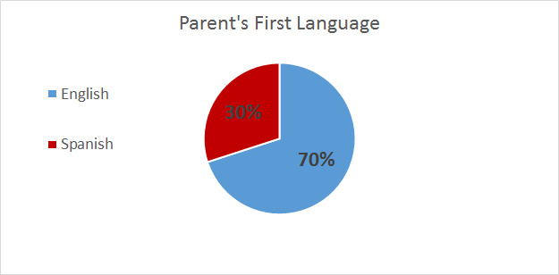
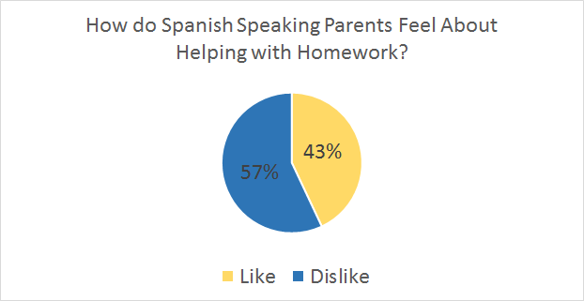
To gain parents’ insight on the topic of homework, an online questionnaire was posted so that parents could answer the questions at their convenience. A total of twenty-three parents and guardians responded to the questionnaire. Out of the twenty-three parent responses, the grade level of their child(ren) ranged from Pre-Kindergarten to 11th grade. Seven out twenty three of the parents spoke Spanish as their first language. Of those Spanish speaking parents, four out of seven stated that they did not feel comfortable helping their students with homework. Seven out of twenty-three English speaking parents stated that they enjoyed helping their students with homework, and only three out of twenty-three felt uncomfortable helping their students with homework. Four out of twenty-three parents were unable to assist their students with assignments at all due to time or education. 30% of the parents who responded to our questionnaire, had a college degree, 35% had received some college education, 22% had a high school diploma, 4% had a received their GED, and 8% did not complete high school.
The parents stated that the majority of the assignments that their children receive from school are in Math and Reading. Most of the students’ Math homework consisted of worksheets that were to be completed on their own or with some assistance from anyone in the household. The students’ Reading homework consisted of books that were at or just below their guided reading level so that students were able to read on their own or to a family member at home. Although the homework that was being sent home for students was meant to be something that they could do independently, 35% of the parents stated that their student(s) struggled, displayed stress or frustration while completing their homework.
Out of eight teacher responses, the teachers who participated in the data have been teaching from a range of 1 year to 17 years. 6 out of 8 teachers said that they do have English Language Learners. From the teachers’ point of view, most teachers felt comfortable giving their students homework as long as they actually took the time to complete it at home. Teachers feel that homework should be seen as a benefit for students to touch up, review, and master concepts that have been previously worked on during class time. However, homework is only effective when students are the ones who complete it and bring it back to school. Math and Reading were the most prevalent subjects in which teachers’ assigned homework to their students. The most common types of homework that were assigned to students were math worksheets and reading logs to track their reading progress at home. For younger grades, some students were expected to complete spelling and site words for homework whereas older grades such as fourth through sixth graders had more vigorous homework assignments such as projects.
There were various types of differentiation methods used when assigning homework to English Language Learners. The most prominent methods used were leveled reader books, assigning school work in their preferred language, and assigning homework assignments at their instructional level that best suites each student. While some teachers feel strongly about students working independently on their homework, others feel it is necessary to have help from older siblings, parents, or guardians in order to retain previously learned material. Those teachers who felt that students should work independently on homework also made it known that they only assign homework that they are capable of doing on their own. Other teachers feel that students learn best and retain the given information with the help of someone else. Based upon the data we obtained, it is obvious that teachers differentiate every assignment for each student to correlate with their abilities.

Conclusion
In our literature review, research showed that teachers should give assignments that are developmentally appropriate. Based on our questionnaire responses, 3 of the 4 teachers who had ESL students said they differentiate by assigning books at the students' individual reading levels. It was surprising that only two teachers mentioned allowing the students to read books that were written in their first language.
Teachers without ESL students also made comments about assigning homework based on academic level so that students were able to complete it independently. It appeared that most of the teachers differentiated homework in the same manner, based on developmental levels, but not necessarily language ability.
We didn't have any responses that indicated teachers assigned different homework assignments each day, which did not match research from the literature review. Especially with ESL students who need to learn by experiencing language in different ways, we would recommend that more teachers tried to vary the types of assignments that are sent home each day.
Student, parent and teacher participant responses showed that math and reading were the most common assignments given and received. According to our literature review, math assignments should encourage higher level thinking skills based on a few problems. One parent response stated that their child received too many worksheets. Some parents also thought the problems were too hard for them to solve, so they were unable to help the students. Most parents were supportive and positive in regards to the homework their child received, although the assignments may have been repetitive.
The data obtained from these interviews and questionnaires show that students have a difficult time completing homework, whether they may have a language barrier or not. It is recommended that more teachers obtain further education so they are able to meet not only the needs of English Language Learners and their parents, but all students.

References
Alleman, J., Ley, R., Knighton, B., Botwinski, B., & Middlestead, S. (2010). Homework
Done Right. Educational Leadership, 68(1). Retrieved November 14, 2014.
Bang, H., Suarez-Orozco, C., & O'Connor, E. (2011). American Journal of Education,
118(1), 25-55. Retrieved November 10, 2014, from JSTOR.
Baum, S., & Flores, S. M. (2011). Higher Education and Children in Immigrant Families.
Future of Children, 21(1), 171-193. Retrieved from ERIC.
Batalova, J. (2012). U.S. Immigrant Population by State and County |
migrationpolicy.org. Retrieved November 22, 2014, from
http://www.migrationpolicy.org/programs/data-hub/charts/us-immigrant-population-state-and-county?width=1000&height=850&iframe=true
Caperton, G., Washington, S. J., & Bushaw, W. J. (2011). Teacher Voices: Immigration,
Language and Culture. Retrieved from The College Board Advocacy & Policy Center website: http://www.socialimpactexchange.org/sites/www.socialimpactexchange.org/files/Teacher%20Voices%20-%20Immigration,%20Language,%20Culture.pdf
Crosnoe, R., & López Turley, R. N. (2011). K–12 Educational Outcomes of Immigrant
Youth. Future of Children, 21(1), 129-152. Retrieved from ERIC.
Danielson, M., Strom, B., & Kramer, K. (2011). Real Homework Tasks: A Pilot Study of
Types, Values, and Resource Requirements. Educational Research Quarterly,
35(1), 17-32. Retrieved November 30, 2014, from EBSCO Host.
Drummond, K., & Stipek, D. (January 2004). Low-Income Parents' Beliefs about Their
Role in Children's Academic Learning. The Elementary School Journal, 104(3),
197-213. Retrieved November 12, 2014, from JSTOR.
ESL - Curriculum Instruction and Assessment - Omaha Public Schools. (2014).
Retrieved from http://district.ops.org/DEPARTMENTS/CurriculumInstructionandAssessment/ESL.aspx#6901169-mission-and-philosophy
How the United States Immigration System Works: A Fact Sheet | Immigration Policy
Center. (2014, March 1). Retrieved from http://www.immigrationpolicy.org/just-facts/how-united-states-immigration-system-works-fact-sheet
Hunemorder, R. (2005, November 27). ELL in Elementary Schools: Pull-out ESL.
Retrieved November 22, 2014, from http://sitemaker.umich.edu/356.hunemorder/pull-out_esl_
Kohn, A. (January 2007). Rethinking Homework. Retrieved November 30, 2014.
Mintz, S., & McNeal, S. (2013). Immigration Restriction. Retrieved November 22, 2014,
from http://www.digitalhistory.uh.edu/disp_textbook.cfm?smti=2&psid=3295
Protheroe, N. (September 2009). Good Homework Policy. NAESP. Retrieved
November 30, 2014.
Rosenblum, M. R., Kandel, W. A., Seelke, C. R., & Wasem, R. E. (2012). Mexican
Migration to the United States: Policy and Trends. Congressional Research Service.
Salinas, C., Sullivan, C., & Wacker, T. (2007). Curriculum Considerations for
Late-arrival High School Immigrant Students: Developing a Critically Conscious
World Geography Studies Approach to Citizenship Educatio. Journal of Border
Educational Research, 6(2), 56.
Schrat Carr, N. (2013). Increasing the Effectiveness of Homework for All Learners in the
Inclusive Classroom. School Community Journal, 23(1), 169-179. Retrieved
December 1, 2014, from ERIC.
Sutherland, L. (2008). Reading in Science: Developing High-Quality Student Text and
Supporting Effective Teacher Enactment. The Elementary School Journal,
109(2), 162-180. Retrieved November 28, 2014, from JSTOR.
Tas, Y., Sungur Vural, S., & Oztekin, C. (May 2014). A study of science teachers'
homework practices. Research in Education, 91, 45-62. Retrieved November 6,
2014, from EBSCO Host.
U.S. States Department. (2014). Family Immigration. Retrieved from
http://travel.state.gov/content/visas/english/immigrate/types/family.html
Vatterott, C. (2010). Five Hallmarks of Good Homework. Educational Leadership, 68(1),
10-15. Retrieved November 12, 2014.
Vatterott, C. (n.d.). Chapter 1. The Cult(ure) of Homework. ASCD. Retrieved December
1, 2014.
Vatterott, C. (n.d.). Chapter 2. Homework in the Context of the New Family. ASCD.
Retrieved November 30, 2014.
What research says about the value of homework: Research review. (2007, February
7). The Center for Public Education. Retrieved December 1, 2014.
Zehler, A., Adger, C., Coburn, C., Arteagoitia, I., Williams, K., & Jacobson, L. (2008,
June). Preparing to Serve English language learner students: school districts with
emerging English language learner Communities. Issues & Answers, 1-61. Retrieved from ERIC.

